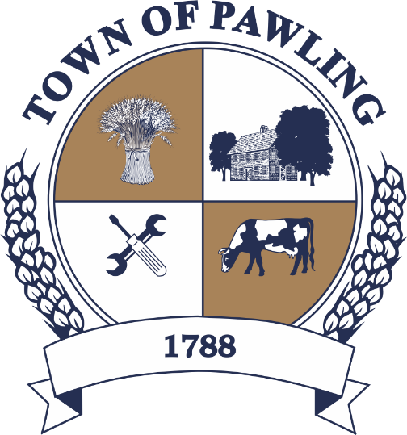
Town of Pawling Town Board
Pawling Town Hall
160 Charles Colman Blvd
Pawling, NY 12564

Regular Meeting of the Town Board

Meeting will be broadcast live on the Town of Pawling YouTube page

Wednesday, January 14th, 2026
6:00PM

Cathy Giordano, Supervisor
Coleen Snow, Deputy Supervisor / Councilwoman
Martin Mygan, Councilman
James McCarthy, Councilman
Corinne Musella-Pitt, Councilwoman

Cheryl Knowles, Town Clerk

RULES FOR PUBLIC COMMENT:

1. Each presentation to the Board made by an individual shall be limited to three (3) minutes in duration, unless extended by agreement by the Town Supervisor/ designee

2. Comments should be directed to the Board. Comments should be made in a respectful manner to the Board and from the Board to the community.

The Town Supervisor or designee may:

a. Interrupt, warn, or terminate an individual’s comment when the comment is personally directed, abusive or obscene.

b. Request that any individual leave the meeting when that individual fails to observe reasonable decorum.

c. Call for a recess or an adjournment to another time.

The intent of these rules are:

1. To allow members of the public a fair and adequate opportunity to be heard.

2. To assure that the regular agenda of the Town Board is completed; and

3. To recognize the nature of the Board and community’s time and to use that time effectively.

Meeting Agenda

- Roll Call of the Town Board
- Pledge of Allegiance
- Executive Session – To discuss the medical, financial, credit or employment history of a particular person or corporation, or matters leading to the appointment, employment, promotion, demotion, discipline, suspension or removal of a particular person or corporation.

- Public Comment on Agenda Items
- Resolutions
- Discussion
Town Clerk Cheryl Knowles Received RMC Designation from NYSTCA

Dewey Lane Bridge Update – Bid opening occurred January 9, 2026 at 10 AM

Tax bills will go out January 15th

- Town Board Items for Special Consideration & New Business
- Privilege of the Floor with respect to Agenda & Non-Agenda items (3 minutes)
- Adjournment

RESOLUTIONS
RESOLUTION 2026-036
Payment of Bills for the Town of Pawling

WHEREAS, the Town of Pawling Senior Account Clerk has reviewed and prepared the vouchers for Town of Pawling and has offered them for review, and
WHEREAS, the vouchers have been approved in accordance with the Town of Pawling policy, and
WHEREAS, the vouchers have been numbered through , and
NOW THEREFORE BE IT RESOLVED, that the town board of the Town of Pawling hereby accepts the vouchers as prepared and on the recommendation of the Senior Account Clerk and hereby authorizes payment of said vouchers for the Town of Pawling on this date in the amount of $490,331.82.

RESOLUTION 2025-037
Billing for Pawling Water District No. 2

WHEREAS, Pawling Water District No. 2 bills need to be approved by the Pawling Town Board, and
WHEREAS, the bills have been prepared and submitted in the amount of $14,124.85 for the period of October 1, 2025 through December 31, 2025 by the Clerk to the Water District, Catherine Giordano, and
NOW THEREFORE BE IT RESOLVED, that the Town Board of the Town of Pawling hereby accepts the billing as recommended for Pawling Water District No.2.

RESOLUTION 2026-038
Setting Parks, Recreation, and Facility Use Fees for 2026

WHEREAS, the Town of Pawling Recreation Department has proposed the following fees for Parks and Recreation programs and services for 2026:

TABLES/CHAIRS | $ PRICE $
EXTRA CHAIRS
1-20 | included in all indoor rentals
21-40 | 15
41-60 | 30
61-80 | 50
81-100 | 70
100-150 | 100
151-200 | 150
201 & up | 175
LONG TABLES (8ft)
1-2 | included in all indoor rentals
3-5 | 15
6-10 | 30
11-15 | 50
16-20 | 70
21 & up | 100
ROUND TABLES
1-5 | 15
6-10 | 30
11-15 | 50
16-20 | 70
21 & up | 100
PICNIC TABLES- LAKESIDE |  | PICNIC TABLES- MURROW
1-10 | included | 1-4 | included
11-15 | 30 | not available | not available
16-20 | 50 | not available | not available
EXTRAS |  | extra deposit needed?
Kitchen access: includes staff on site | 200/up to 4 hours | yes
Movie kit (projector, speaker system, projector screen)* | 10/event
Stage kit (wireless mic, speaker system)* | 10/event
Private Swimming area (camp area- wknds only) | 400/20 people + 5/pp after that
Lights on fields/rink | 20/hr residents | 10/hr non-profits | 25/hr non-res

Music By The Lake Concerts | $0 | $0
Over 35 Basketball | $0 | $0
Pawling Book Club | $0 | $0
Rec Club After School | varies | n/a
Rec Club Before School | varies | n/a
Senior Fitness | $0 | $0
Senior Lunch of the Month | $0 | n/a
Tiger Running Club | $25 per week | $35 per week
Toddler Troop Playgroup | $0 | $0
Trick or Treat Trail | $0.00 | n/a
Walking Club | $0 | $0
*Additional programs will be added as we continue to grow and offer new programs
RECREATION MEMBERSHIP | $ RESIDENT PRICING | NON-RESIDENT $
Pickleball Adult (April 15 - November 15) | $50 | $125
Pickleball Senior 62+ (April 15 - November 15) | $25 | $75
Pickleball Youth (April 15 - November 15) | $25 | $75

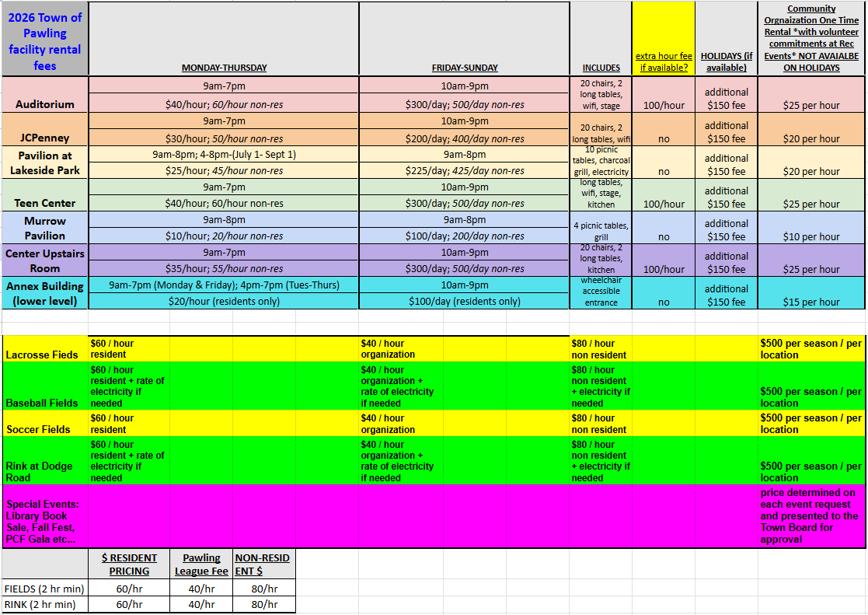

RESOLUTION 2026-039
GRANT MANAGEMENT SERVICES
WHEREAS, the Town of Pawling has been successful in securing a wide variety of grants over the past years; and
WHEREAS, the Town of Pawling is required to provide grant management and administration of each grant which includes, but is not limited to summary reports; drawdown requests; coordination with local, state and federal officials and program staff; and other duties as may be required to manage and closeout program funding; and
WHEREAS, the Town of Pawling had a General Services contract with Laberge Group as well as an annual Grant Writing Contract; and
WHEREAS, to continue services with the Laberge Group a Contract Addendum must be reviewed and executed; and
NOW THEREFORE BE IT RESOLVED, that the Town Board authorizes and directs the Town Supervisor to execute a contract addendum 2022094-07 to be billed hourly and not to exceed $30,000 for the continuation of grant administration services for the grant funded projects associated with Laberge Group job number 2022094.

RESOLUTION 2026-040
Appointment of the Dog Control Officer for the Town of Pawling

BE IT RESOLVED, that Kenneth Wallace is hereby appointed as Dog Control Officer for the Town of Pawling for calendar year 2026.

NOW THEREFORE BE IT FURTHER RESOLVED, that said Kenneth Wallace shall receive a $20,000 salary as set forth in the duly adopted Budget for the Town of Pawling for calendar year 2026 and that said salary shall be payable in 52 weekly installments retroactive to and commencing on January 1, 2026.

RESOLUTION 2026-041
Appointment of a Legislative Aide

NOW THEREFORE BE IT RESOLVED, that Joan Sclavounos is hereby appointed as Legislative Aide to the Town Board with a start date of January 15, 2026 and shall be compensated at the annual salary of $53,000.00.

RESOLUTION 2026-42
Dewey Lane Bridge
AUTHORIZING SUPERVISOR TO SIGN SUPPLEMENTAL AGREEMENT

WHEREAS, in connection with the grant funding to the Town of Pawling for the repair and replacement of the Dewey Lane Culvert Pin: 8762.23, the Town is in receipt of a certain Supplemental Agreement No. 1 to D040210, a copy of which is annexed hereto and hereby incorporated herein, which agreement amends the grant agreement under D040210 in order to account for the right of way acquisition and other funding required to complete the Project; and

WHEREAS, the Town of Pawling Town Board wishes to authorize the Town Supervisor to execute said Supplemental Agreement in the form annexed hereto;

NOW, THEREFORE, BE IT RESOLVED, that the Town Board of the Town of Pawling hereby authorizes the Supervisor to execute the Supplemental Agreement and take any other steps necessary to give effect to this resolution.

