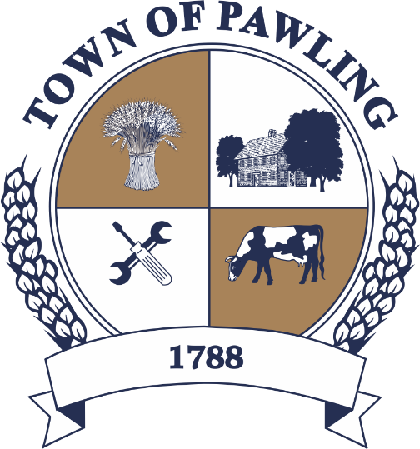
Town of Pawling Town Board
Pawling Town Hall
160 Charles Colman Blvd
Pawling, NY 12564

Special Meeting of the Town Board

Meeting will be broadcast live on the Town of Pawling YouTube page

Wednesday, January 28, 2026
10:00 AM

Cathy Giordano, Supervisor
Coleen Snow, Deputy Supervisor / Councilwoman
Martin Mygan, Councilman
James McCarthy, Councilman
Corinne Musella-Pitt, Councilwoman

Cheryl Knowles, Town Clerk

RULES FOR PUBLIC COMMENT:

1. Each presentation to the Board made by an individual shall be limited to three (3) minutes in duration, unless extended by agreement by the Town Supervisor/ designee

2. Comments should be directed to the Board. Comments should be made in a respectful manner to the Board and from the Board to the community.

The Town Supervisor or designee may:

a. Interrupt, warn, or terminate an individual’s comment when the comment is personally directed, abusive or obscene.

b. Request that any individual leave the meeting when that individual fails to observe reasonable decorum.

c. Call for a recess or an adjournment to another time.

The intent of these rules are:

1. To allow members of the public a fair and adequate opportunity to be heard.

2. To assure that the regular agenda of the Town Board is completed; and

3. To recognize the nature of the Board and community’s time and to use that time effectively.

Meeting Agenda

- Roll Call of the Town Board
- Pledge of Allegiance
- Resolutions
- Privilege of the Floor with respect to Agenda & Non-Agenda items (3 minutes)
- Adjournment
RESOLUTIONS
RESOLUTION 2026-044
Assessor
WHEREAS, the Town of Pawling Town Board desires to appoint a Town Assessor to fill a current vacancy in the position; and

WHEREAS, the previous Town Assessor’s six-year term commenced on October 1, 2025 and was set to expire on September 30, 2031; and

WHEREAS, the Town Board desires to appoint Seth Plawsky as interim Town Assessor for the remainder of the six-year term.

NOW, THEREFORE BE IT RESOLVED, that the Town of Pawling Town Board hereby appoints Seth Plawsky as the Assessor for the Town of Pawling; and

BE IT FURTHER RESOLVED, that Seth Plawsky shall be compensated with an annual salary of $37,500.00; and

BE IT FURTHER RESOLVED, that Seth Plawsky is hereby appointed for a term commencing January 28, 2026 and expiring September 30, 2031.

RESOLUTION 2026-045
SCAR Stipend

WHEREAS, the Town Board of the Town of Pawling desires that the Town Assessor, Seth Plawsky, oversee and defend Small Claims Assessment Review (SCAR) proceedings pertaining to the 2025 assessment roll which currently remain unresolved; and

WHEREAS, this work to address the unresolved proceedings will require the Town Assessor’s immediate attention and commitment of time above and beyond the usual course of his duties.

NOW, THEREFORE BE IT RESOLVED, that the Town of Pawling Town Board hereby authorizes a one-time stipend to the Town Assessor in the amount of $6,500.00 to oversee and defend Small Claims Assessment Review (SCAR) proceedings pertaining to the 2025 assessment roll.

RESOLUTION 2026-046
Appointment of a Recreation Assistant

BE IT RESOLVED, that the Town of Pawling Town Board hereby appoints Annie Bellucci as a part-time Recreation Assistant at the rate of $19.00 per hour, for up to 17.5 hours per week; and
BE IT FURTHER RESOLVED, that this appointment shall begin as of January 27, 2026.

