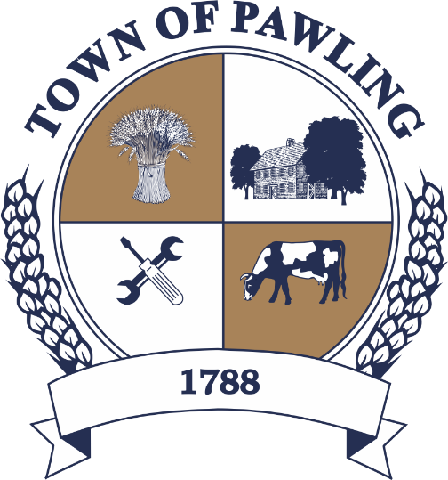
Town of Pawling Town Board
Pawling Town Hall
160 Charles Colman Blvd
Pawling, NY 12564

Regular Meeting of the Town Board

Meeting will be broadcast live on the Town of Pawling YouTube page

Wednesday, February 11th, 2026
6:00PM

Cathy Giordano, Supervisor
Coleen Snow, Deputy Supervisor / Councilwoman
Martin Mygan, Councilman
James McCarthy, Councilman
Corinne Musella-Pitt, Councilwoman

Cheryl Knowles, Town Clerk

RULES FOR PUBLIC COMMENT:

1. Each presentation to the Board made by an individual shall be limited to three (3) minutes in duration, unless extended by agreement by the Town Supervisor/ designee

2. Comments should be directed to the Board. Comments should be made in a respectful manner to the Board and from the Board to the community.

The Town Supervisor or designee may:

a. Interrupt, warn, or terminate an individual’s comment when the comment is personally directed, abusive or obscene.

b. Request that any individual leave the meeting when that individual fails to observe reasonable decorum.

c. Call for a recess or an adjournment to another time.

The intent of these rules are:

1. To allow members of the public a fair and adequate opportunity to be heard.

2. To assure that the regular agenda of the Town Board is completed; and

3. To recognize the nature of the Board and community’s time and to use that time effectively.

Meeting Agenda

- Roll Call of the Town Board
- Pledge of Allegiance
- Acknowledgement of Minutes
- December 10th, 2025
- January 7th, 2026
- January 14th, 2026
- January 28th, 2026
- Public Comment on Agenda Items
- Presentations
Wendell Weber – Little League fields and storage
- Resolutions
- Discussion
Message from the Tax Collector Regarding Postmarks
Changes at the US Postal Service - Postmark Dates and Timely Tax Payments

USPS postmarks are typically applied at regional processing facilities, not at the point of mailing.

Due to changes in USPS transportation operations, mail may not be postmarked on the same day it is deposited.

To ensure the postmark date matches the mailing date, present your mail at a USPS retail location and request a manual (local) postmark at the counter.

The postmark date determines whether a tax payment meets the deadline.

- Town Board Items for Special Consideration & New Business
- Privilege of the Floor with respect to Agenda & Non-Agenda items (3 minutes)
- Adjournment

RESOLUTIONS
RESOLUTION 2026-047
Payment of Bills for the Town of Pawling

WHEREAS, the Town of Pawling Senior Account Clerk has reviewed and prepared the vouchers for Town of Pawling and has offered them for review, and
WHEREAS, the vouchers have been approved in accordance with the Town of Pawling policy, and
WHEREAS, the vouchers have been numbered 20251718 through 20251877, and
NOW THEREFORE BE IT RESOLVED, that the town board of the Town of Pawling hereby accepts the vouchers as prepared and on the recommendation of the Senior Account Clerk and hereby authorizes payment of said vouchers for the Town of Pawling on this date in the amount of $389,280.57.

RESOLUTION 2026-055
Establishing Pay Scale for Recreation Department in the Town of Pawling
WHEREAS, the Town of Pawling Recreation Department employs seasonal and full-time employees necessary to provide the various recreation programs which are funded by the Town, and
NOW THEREFORE BE IT RESOLVED, that the Town Board hereby establishes the wages for the following employees employed or to be employed by the Town of Pawling Recreation Department for calendar year 2026 to be paid bi-weekly commencing with the first Friday following the start of employment as hereinafter set forth:
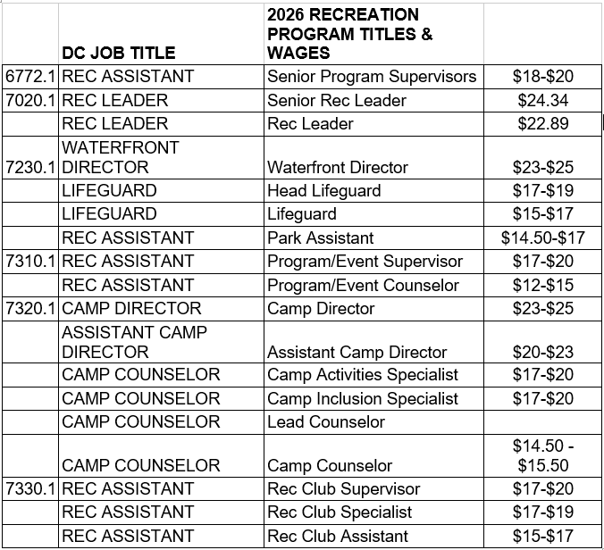

RESOLUTION 2026-056
Appointment – Deputy Town Clerk
WHEREAS, the position of Deputy Town Clerk is an appointed position serving for a term of one year at the pleasure of the Town Clerk and,
WHEREAS, the Town Clerk of the Town of Pawling hereby appoints Bridget Burns, now, therefore, be it
NOW THEREFORE BE IT RESOLVED, that Bridget Burns is hereby appointed Deputy Town Clerk for a one-year term ending December 31, 2026; and
BE IT FURTHER RESOLVED, that Bridget Burns shall be compensated with an annual salary of $50,000 beginning February 23, 2026.

RESOLUTION 2026-057
Appointment - Full Time Maintenance Worker
WHEREAS, a full-time maintenance worker vacancy exists in Building and Grounds, and

WHEREAS, the Supervisor of Building and Grounds would like to fill this position with Connor Dickinson, and

NOW THEREFORE BE IT RESOLVED, that Connor Dickinson is hereby appointed as full-time maintenance working in Buildings and Grounds at the hourly rate of $24.00 effective February 23, 2026.

RESOLUTION 2026-058
Appointment – Part Time Recreation Club Assistant
WHEREAS, a part time Recreation Club Assistant vacancy exists in the Recreation Department, and
WHEREAS, the Recreation Director would like to fill this position by hiring Jeremy Cozzocrea.
NOW THEREFORE BE IT RESOLVED, that the Town Board hereby appoints Jeremy Cozzocrea as part-time Recreation Club Assistant at Town of Pawling Recreation at the rate of $15.00 per hour; and
BE IT FURTHER RESOLVED, that this appointment shall begin as of February 10th, 2026.

