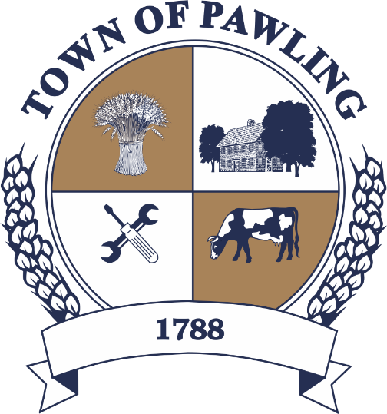
Town of Pawling Town Board
Pawling Town Hall
160 Charles Colman Blvd
Pawling, NY 12564

Special Meeting of the Town Board

Meeting will be broadcast live on the Town of Pawling YouTube page

Wednesday, February 18th, 2026
6:00PM

Cathy Giordano, Supervisor
Coleen Snow, Deputy Supervisor / Councilwoman
Martin Mygan, Councilman
James McCarthy, Councilman
Corinne Musella-Pitt, Councilwoman

Cheryl Knowles, Town Clerk

RULES FOR PUBLIC COMMENT:

1. Each presentation to the Board made by an individual shall be limited to three (3) minutes in duration, unless extended by agreement by the Town Supervisor/ designee

2. Comments should be directed to the Board. Comments should be made in a respectful manner to the Board and from the Board to the community.

The Town Supervisor or designee may:

a. Interrupt, warn, or terminate an individual’s comment when the comment is personally directed, abusive or obscene.

b. Request that any individual leave the meeting when that individual fails to observe reasonable decorum.

c. Call for a recess or an adjournment to another time.

The intent of these rules are:

1. To allow members of the public a fair and adequate opportunity to be heard.

2. To assure that the regular agenda of the Town Board is completed; and

3. To recognize the nature of the Board and community’s time and to use that time effectively.

Meeting Agenda

- Roll Call of the Town Board
- Pledge of Allegiance
- Public Hearing - Community Development Block Grant (CDBG) application for ADA Compliant Bathrooms and Sidewalk at Murrow Park
- Resolutions
- Privilege of the Floor with respect to Agenda & Non-Agenda items (3 minutes)
- Adjournment

RESOLUTIONS
RESOLUTION 2026-059
Authorizing the Submission of the 2026 Community Development Block Grant (CDBG) application for ADA Compliant Bathrooms and Sidewalk at Murrow Park
WHEREAS, the Town of Pawling (hereinafter referred to as the Municipality) is participating in the 2026 Dutchess County Community Development Block Grant Consortium, and

WHEREAS, input from citizens and groups has been received and considered at a public hearing, and

WHEREAS, an application has been prepared for the above referenced activity which addresses our community concerns, and

NOW THEREFORE BE IT RESOLVED, that the 2026 application to the Dutchess County Community Development Block Grant Program for the above referenced activity is approved, and

BE IT FURTHER RESOLVED, that the submission of the application to the Dutchess County Department of Planning and Development is authorized, and

BE IT FURTHER RESOLVED, to the extent all or any actions hereby authorized have been executed and/or performed by the Town all are hereby ratified and confirmed and the Resolution takes effect immediately.

RESOLUTION 2026-060
Appointment – Full Time Highway Department Laborer
WHEREAS, a full time Laborer vacancy exists in the Highway Department, and
WHEREAS, the Highway Supervisor would like to fill this position by hiring Kristofer Whalen.
NOW THEREFORE BE IT RESOLVED, that the Town Board hereby appoints Kristofer Whalen as full-time Laborer at Town of Pawling Highway Department at the rate of $24.00 per hour; and
BE IT FURTHER RESOLVED, that this appointment shall begin as of February 17th, 2026.

