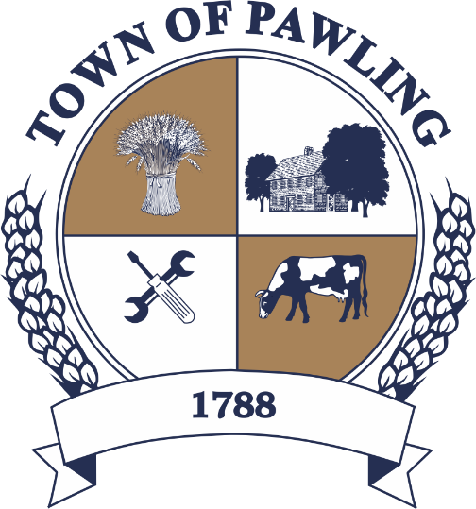
Town of Pawling Town Board
Pawling Town Hall
160 Charles Colman Blvd
Pawling, NY 12564

Regular Meeting of the Town Board

Meeting will be broadcast live on the Town of Pawling YouTube page

Wednesday, February 4th, 2026
6:00PM

Cathy Giordano, Supervisor
Coleen Snow, Deputy Supervisor / Councilwoman
Martin Mygan, Councilman
James McCarthy, Councilman
Corinne Musella-Pitt, Councilwoman

Cheryl Knowles, Town Clerk

RULES FOR PUBLIC COMMENT:

1. Each presentation to the Board made by an individual shall be limited to three (3) minutes in duration, unless extended by agreement by the Town Supervisor/ designee

2. Comments should be directed to the Board. Comments should be made in a respectful manner to the Board and from the Board to the community.

The Town Supervisor or designee may:

a. Interrupt, warn, or terminate an individual’s comment when the comment is personally directed, abusive or obscene.

b. Request that any individual leave the meeting when that individual fails to observe reasonable decorum.

c. Call for a recess or an adjournment to another time.

The intent of these rules are:

1. To allow members of the public a fair and adequate opportunity to be heard.

2. To assure that the regular agenda of the Town Board is completed; and

3. To recognize the nature of the Board and community’s time and to use that time effectively.

Meeting Agenda

- Roll Call of the Town Board
- Pledge of Allegiance
- Public Comment on Agenda Items
- Presentations:
Gabrielle Semel/Pawling Community Garden
Bulk Pickup Discussion
- Resolutions
- Discussion
Message from the Tax Collector Regarding Postmarks
Changes at the US Postal Service - Postmark Dates and Timely Tax Payments

USPS postmarks are typically applied at regional processing facilities, not at the point of mailing.

Due to changes in USPS transportation operations, mail may not be postmarked on the same day it is deposited.

To ensure the postmark date matches the mailing date, present your mail at a USPS retail location and request a manual (local) postmark at the counter.

The postmark date determines whether a tax payment meets the deadline.

- Town Board Items for Special Consideration & New Business
- Privilege of the Floor with respect to Agenda & Non-Agenda items (3 minutes)
- Adjournment

RESOLUTIONS
RESOLUTION 2026-047
Payment of Bills for the Town of Pawling

WHEREAS, the Town of Pawling Senior Account Clerk has reviewed and prepared the vouchers for Town of Pawling and has offered them for review, and
WHEREAS, the vouchers have been approved in accordance with the Town of Pawling policy, and
WHEREAS, the vouchers have been numbered 2026 through 2026 , and
NOW THEREFORE BE IT RESOLVED, that the town board of the Town of Pawling hereby accepts the vouchers as prepared and on the recommendation of the Senior Account Clerk and hereby authorizes payment of said vouchers for the Town of Pawling on this date in the amount of $.
RESOLUTION 2026-048
Appointment of a Permanent Part Time Laborer

NOW THEREFORE BE IT RESOLVED, that Sean Sweeney is hereby appointed as a permanent part time laborer and shall be compensated at $18.50 per hour, for twenty hours per week.

RESOLUTION 2026-049
RESOLUTION TO SET A PUBLIC HEARING ON PROPOSED SEWER RATE INCREASE
WHEREAS, the Pawling Joint Sewer Commission (PJSC) has recommended that the Town of Pawling overall Operation and Maintenance (O&M) rate be increased by twenty-one percent (21%) for sewer uses; and
WHEREAS, the proposed rate increase requires a public hearing; and
WHEREAS, the PJSC has provided a chart showing the comparison between the current rate and the proposed increased rate; and
WHEREAS, said comparison chart is available for review and consideration.
NOW, THEREFORE BE IT RESOLVED, that the Town of Pawling Town Board hereby sets a public hearing on the proposed Rate Increase for March 4, 2026, at 6:00pm, or as soon thereafter as the matter may come to be heard, in the Town Hall, 160 Charles Colman Blvd,, Pawling, New York

RESOLUTION 2026-50
Resolution to Adopt the New York State Climate Smart Communities Pledge
WHEREAS, the Town of Pawling recognizes that climate change poses risks to our community’s infrastructure, environment, and residents, and
WHEREAS, the New York State Climate Smart Communities (CSC) Program provides guidance and support for local actions that reduce greenhouse gas emissions and strengthen climate resilience, and
WHEREAS, adopting the CSC Pledge is the first step toward participation in the program and eligibility for related grants and resources.
IT IS HEREBY RESOLVED that Town Pawling, in order to reduce greenhouse gas emissions and adapt to a changing climate, adopts the New York State Climate Smart Communities pledge, which comprises the following ten elements:

- Build a climate-smart community.
- Inventory emissions, set goals, and plan for climate action.
- Decrease energy use.
- Shift to clean, renewable energy.
- Use climate-smart materials management.
- Implement climate-smart land use.
- Enhance community resilience to climate change.
- Support a green innovation economy.
- Inform and inspire the public.
- Engage in an evolving process of climate action.

RESOLUTION 2026-51
LETTER OF SUPPORT FOR FUNCTIONAL CLASSIFICATION CHANGES
WHEREAS, the Dutchess County Transportation Council has requested a letter of support in favor of changing the Functional Classification of certain roadways located within the Town of Pawling as outlined in the table below:
Change ID # | Route/Road | From | To | Owner | Municipality | Current Functional Class | Proposed Functional Class
9 | CR 20-W.  Dover Rd | 2010 UAB [0.27 miles north of Dodge Road] | CR 21- Pleasant Ridge Rd | County | Town of Dover/ Pawling | FC 9- Rural local | FC 8- Rural minor collector
10 | CR 20-W.  Dover Rd | Lakeside Dr. | 2010 UAB [0.27 miles north of Dodge Road] | County | Town of Pawling | FC 19- Urban local | FC 18- Urban minor collector
16 | CR 69- Dutcher Ave | NY 55 | W. Main St | County | Town of Pawling | FC 19- Urban local | FC 18- Urban minor collector

NOW, THEREFORE, BE IT RESOLVED, that the Town Board of the Town of Pawling hereby authorizes that a letter be issued in support of the above-described Functional Classification changes; and
BE IT FURTHER RESOLVED, that Supervisor Giordano is hereby authorized to execute and transmit said letter of support on behalf of the Town of Pawling Town Board.
Resolution 2026-052
Appointment – Board of Assessment Review

Whereas, the term of Nancy Reilly has expired on the Board of Assessment Review, and

Whereas, Nancy Reilly wishes to continue serving on the Board of Assessment Review,

Resolved, that Nancy Reilly is hereby reappointed to the Board of Assessment Review for a term of 5 years beginning February 4, 2026 and ending September 30, 2030.

RESOLUTION 2026–053
RESOLUTION TO AUTHORIZE LETTER OF INTENT TO APPLY FOR 2026 COMMUNITY DEVELOPMENT BLOCK GRANT (CDBG)
WHEREAS, the Town of Pawling Town Board desires to submit a Letter of Intent to apply for the 2026 Dutchess County Community Development Block Grant (CDBG) for the purpose of constructing an Americans with Disabilities Act (ADA) accessible bathroom and accessible path at the Murrow Park (the “Project”); and
WHEREAS, the Letter of Intent is the first step in determining whether the Project is eligible to receive 2026 CDBG Program funding; and
NOW THEREFORE BE IT RESOLVED, that the Town Board of the Town of Pawling does hereby authorize the Supervisor to execute and submit said Letter of Intent to Dutchess County Department of Planning & Development.
RESOLUTION 2026-054
Authorization for Town Administrator Signature for Equitable Business Opportunities (“EBO”) Portal

RESOLVED that the Town Board hereby authorizes Cathy Giordano, the Town Supervisor, to sign the certification form required to alter an EBO account as needed for PIN 8762.23 Dewey Lane over Hiller Brook Culvert Rehabilitation and any related documents necessary to carry out its implementation.

