Supervisor Cathy Giordano opened the meeting of the town board of the Town of Pawling at 6:00 PM on February 11, 2026 at Pawling Town Hall, 160 Charles Colman Blvd., Pawling, New York. Present were councilwomen Snow and Pitt, councilmen Mygan and McCarthy and Sarah Ryan, town attorney. Approximately 9 interested citizens also attended.

MINUTES

Supervisor Giordano stated that she would be abstaining from voting on the December 10, 2025 minutes; as she was not on the board at that time and she prepared the minutes. Councilman McCarthy made a motion to acknowledge the minutes of December 10, 2025, seconded by councilwoman Snow, and passed unanimously.

Supervisor Giordano made a motion to acknowledge the minutes of January 7, 2026, seconded by councilman Mygan, motion passed unanimously.

Supervisor Giordano made a motion to acknowledge the minutes of January 14, 2026, seconded by councilwoman Snow, motion passed unanimously.

Supervisor Giordano made a motion to acknowledge the minutes of January 28, 2026, seconded by councilman McCarthy, motion passed unanimously.

PRESENTATION / WENDELL WEBER – LITTLE LEAGUE FIELDS AND STORAGE

Wendell Weber, Supervisor of Buildings & Grounds gave a presentation regarding Little League fields and storage. Mr. Weber discussed his meeting that he had with Nick from Little League and the large punch list of items that they would like as well as information pertaining to a few of the fields and parking lots. A detailed email list was sent to the town board for review from Mr. Weber. Little League is planning to have Opening Day on April 25th or around that time, weather permitting. They would also like to have another movie night this year like they did last year. Sarah Ryan, town attorney advised the board that there is additional information that is needed prior to doing the review for the approval.

RESOLUTIONS

RESOLUTION 2026-047
Payment of Bills for the Town of Pawling

WHEREAS, the Town of Pawling Senior Account Clerk has reviewed and prepared the vouchers for Town of Pawling and has offered them for review, and
WHEREAS, the vouchers have been approved in accordance with the Town of Pawling policy, and
WHEREAS, the vouchers have been numbered 20251718 through 20251877, and
NOW THEREFORE BE IT RESOLVED, that the town board of the Town of Pawling hereby accepts the vouchers as prepared and on the recommendation of the Senior Account Clerk and hereby authorizes payment of said vouchers for the Town of Pawling on this date in the amount of $389,280.57.

MOTION: Supervisor Giordano
SECOND: Councilwoman Pitt

ROLL CALL VOTE:
Councilwoman Snow: “AYE”
Councilwoman Pitt: “AYE”
Councilman Mygan: “AYE”
Councilman McCarthy: “AYE”
Supervisor Giordano: “AYE”
RESOLUTION 2026-055
Establishing Pay Scale for Recreation Department in the Town of Pawling

WHEREAS, the Town of Pawling Recreation Department employs seasonal and full-time employees necessary to provide the various recreation programs which are funded by the Town, and
NOW THEREFORE BE IT RESOLVED, that the Town Board hereby establishes the wages for the following employees employed or to be employed by the Town of Pawling Recreation Department for calendar year 2026 to be paid bi-weekly commencing with the first Friday following the start of employment as hereinafter set forth:

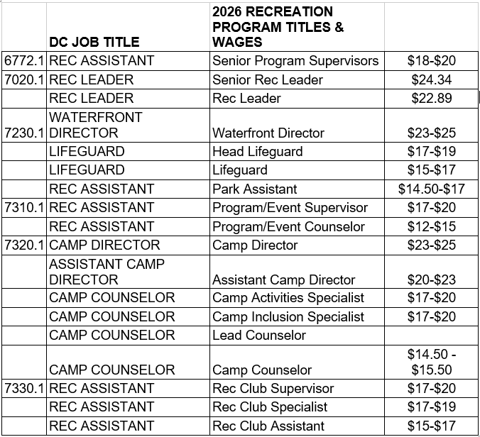

MOTION: Supervisor Giordano
SECOND: Councilwoman Pitt

ROLL CALL VOTE:
Councilwoman Snow: “AYE”
Councilwoman Pitt: “AYE”
Councilman Mygan: “AYE”
Councilman McCarthy: “AYE”
Supervisor Giordano: “AYE”

RESOLUTION 2026-056
Appointment – Deputy Town Clerk

WHEREAS, the position of Deputy Town Clerk is an appointed position serving for a term of one year at the pleasure of the Town Clerk and,
WHEREAS, the Town Clerk of the Town of Pawling hereby appoints Bridget Burns, now, therefore, be it
NOW THEREFORE BE IT RESOLVED, that Bridget Burns is hereby appointed Deputy Town Clerk for a one-year term ending December 31, 2026; and
BE IT FURTHER RESOLVED, that Bridget Burns shall be compensated with an annual salary of $50,000 beginning February 23, 2026.

MOTION: Supervisor Giordano
SECOND: Councilwoman Snow

ROLL CALL VOTE:
Councilwoman Snow: “AYE”
Councilwoman Pitt: “AYE”
Councilman Mygan: “AYE”
Councilman McCarthy: “AYE”
Supervisor Giordano: “AYE”

RESOLUTION 2026-057
Appointment - Full Time Maintenance Worker
WHEREAS, a full-time maintenance worker vacancy exists in Building and Grounds, and
WHEREAS, the Supervisor of Building and Grounds would like to fill this position with Connor Dickinson, and
NOW THEREFORE BE IT RESOLVED, that Connor Dickinson is hereby appointed as full-time maintenance working in Buildings and Grounds at the hourly rate of $24.00 effective February 23, 2026.

MOTION: Supervisor Giordano
SECOND: Councilman McCarthy

ROLL CALL VOTE:
Councilwoman Snow: “AYE”
Councilwoman Pitt: “AYE”
Councilman Mygan: “AYE”
Councilman McCarthy: “AYE”
Supervisor Giordano: “AYE”

RESOLUTION 2026-058
Appointment – Part Time Recreation Club Assistant
WHEREAS, a part time Recreation Club Assistant vacancy exists in the Recreation Department, and
WHEREAS, the Recreation Director would like to fill this position by hiring Jeremy Cozzocrea.
NOW THEREFORE BE IT RESOLVED, that the Town Board hereby appoints Jeremy Cozzocrea as part-time Recreation Club Assistant at Town of Pawling Recreation at the rate of $15.00 per hour; and
BE IT FURTHER RESOLVED, that this appointment shall begin as of February 10th, 2026.

MOTION: Supervisor Giordano
SECOND: Councilwoman Pitt

ROLL CALL VOTE:
Councilwoman Snow: “AYE”
Councilwoman Pitt: “AYE”
Councilman Mygan: “AYE”
Councilman McCarthy: “AYE”
Supervisor Giordano: “AYE”

DISCUSSION

Tax Collector:
Supervisor Giordano read a message from the Tax Collector, Barbara Tyson regarding postmarks.
Changes at the US Postal Service - Postmark Dates and Timely Tax Payments

USPS postmarks are typically applied at regional processing facilities, not at the point of mailing.

Due to changes in USPS transportation operations, mail may not be postmarked on the same day it is deposited.

To ensure the postmark date matches the mailing date, present your mail at a USPS retail location and request a manual (local) postmark at the counter.

The postmark date determines whether a tax payment meets the deadline.

NYSEG:
Supervisor Giordano announced that NYSEG will be trimming trees. They will be keeping the lines clear, for ten feet around the lines.

Supervisor Giordano stated that NYSEG is having two informational meetings. The first is on February 17, 2026 at the Carmel Town Hall and the second on February 24, 2026 at the Bedford Town Hall.

Assessor:
Supervisor Giordano stated that the new assessor, Seth Plawsky will be having office hours on Saturdays from 8:00am – 12:00pm and on Wednesdays from 5:00pm – 8:00pm at the Town Hall.

COUNCILMAN MYGAN
Councilman Mygan also discussed NYSEG and the high increase in rates. Councilman Mygan stated he spoke to Sarah Ryan, town attorney and Ian Loehner, HR Consultant, about labor counsel and getting a list from both of them.

COUNCILWOMAN SNOW
Councilwoman Snow stated that she would like to come up with a schedule for possible workshop meeting, to have different departments come to a meeting. She stated that she would speak to Loretta Rosa, Recreation Director about coming to a future meeting.

COUNCILWOMAN PITT
Councilwoman Pitt agreed with councilwoman Snow regarding having different department heads come to future meetings. Councilwoman Pitt asked for an update on Tremson. Sarah Ryan, town attorney gave a brief update to the town board. Councilwoman Pitt stated that Empress is the biggest bill that the town pays every month, over $47,000. She mentioned that the town will be starting discussions with them soon to extend the five-year contract. She would enjoy being part of those discussion and discussing other options.

SUPERVISOR GIORDANO
Supervisor Giordano stated that she attended the Dutchess County Mayors and Supervisors meeting last week and talked about a meeting they had regarding ambulance service. The Governor has required that all counties come up with a plan by June 19, 2026. They also believe that within two years, the governor will require counties to have some plan for ambulance service.
Supervisor Giordano announced that on Wednesday, February 18, 2026 there will be a special town board meeting, for the purpose of holding a Public Hearing for the Community Development Block Grant (CDBG).

Supervisor Giordano stated that the Public Hearing for the Sewer Commission fees will be held on March 4, 2026 during the regular town board meeting. The fees will be posted on the website.

COUNCILMAN MCCARTHY
Councilman McCarthy suggested the board re-evaluate the reduction in the cost for the July 1st discounted rate on transfer station permits and suggested possibly suspending that this year. Councilman McCarthy asked for an update on the information that the Comptroller has asked for regarding the Sewer District to Route 22 South. Supervisor Giordano advised that all the information Nancy Tagliafierro, prior town attorney requested was provided to her last week, by Cheryl Knowles, Town Clerk. Councilman McCarthy stated that we are no where closer to having the Comptroller okay the district then we were when the town board originally passed the resolution to form the district.

The motion to adjourn the meeting was made by Supervisor Giordano at 6:30pm, seconded by Councilwoman Snow, motion passed unanimously.

Cheryl Knowles
Town Clerk

