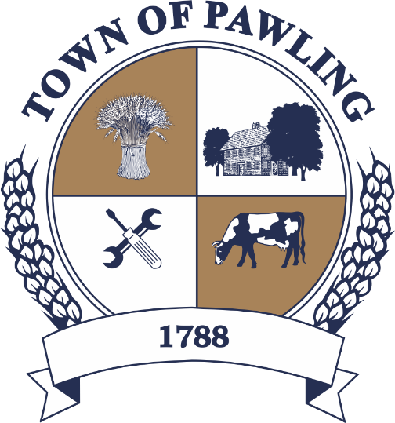
Town of Pawling Town Board
Pawling Town Hall
160 Charles Colman Blvd
Pawling, NY 12564

Regular Meeting of the Town Board

Meeting will be broadcast live on the Town of Pawling YouTube page

Wednesday, March 11th, 2026
6:00PM

Cathy Giordano, Supervisor
Coleen Snow, Deputy Supervisor / Councilwoman
Martin Mygan, Councilman
James McCarthy, Councilman
Corinne Musella-Pitt, Councilwoman

Cheryl Knowles, Town Clerk

RULES FOR PUBLIC COMMENT:

1. Each presentation to the Board made by an individual shall be limited to three (3) minutes in duration, unless extended by agreement by the Town Supervisor/ designee

2. Comments should be directed to the Board. Comments should be made in a respectful manner to the Board and from the Board to the community.

The Town Supervisor or designee may:

a. Interrupt, warn, or terminate an individual’s comment when the comment is personally directed, abusive or obscene.

b. Request that any individual leave the meeting when that individual fails to observe reasonable decorum.

c. Call for a recess or an adjournment to another time.

The intent of these rules are:

1. To allow members of the public a fair and adequate opportunity to be heard.

2. To assure that the regular agenda of the Town Board is completed; and

3. To recognize the nature of the Board and community’s time and to use that time effectively.

Meeting Agenda

- Roll Call of the Town Board
- Pledge of Allegiance
- Public Comment on Agenda Items
- Presentations
  - Ambulance Service Presentation by Empress Representatives
- Resolutions
- Discussion
  - Proposal Linda Grossman Grant Writer
- Town Board Items for Special Consideration & New Business
- Privilege of the Floor with respect to Agenda & Non-Agenda items (3 minutes)
- Adjournment

RESOLUTIONS

RESOLUTION 2026-062
Payment of Bills for the Town of Pawling

WHEREAS, the Town of Pawling Senior Account Clerk has reviewed and prepared the vouchers for Town of Pawling and has offered them for review, and
WHEREAS, the vouchers have been approved in accordance with the Town of Pawling policy, and
WHEREAS, the vouchers have been numbered #20260001 through #20260152, and
NOW THEREFORE BE IT RESOLVED, that the town board of the Town of Pawling hereby accepts the vouchers as prepared and on the recommendation of the Senior Account Clerk and hereby authorizes payment of said vouchers for the Town of Pawling on this date in the amount of $2,133,830.86.

RESOLUTION 2026-063
Authorizing Shared Services Agreement with Dutchess County Sign Shop
WHEREAS, the Town of Pawling intends to enter into an agreement between Dutchess County Department of Works that operate a Sign Shop that provides a wide variety of services including the manufacture of highway signs, and
WHEREAS, Dutchess County agrees to provide these services to the Town of Pawling under this shared services agreement, and
WHEREAS, the pricing for services are:
MUTCD Compliant Road Signs $0.09 per sq. in. of finished sign face
Building Signs $0.10 per sq. in of finished sign face
Stickers and adhesive lettering qty less than 100 units per design - $1.00 each
qty 100 or more units per design – $0.75 each
Highway Detour signs $0.10 per sq. in. of finished sign face
WHEREAS, this agreement shall be effective January 1, 2026 and shall terminate on December 31, 2065, and
NOW THEREFORE BE IT RESOLVED, that the Town Board of the Town of Pawling does hereby authorize the Supervisor to execute this agreement, as noted herein of the Shared Services Agreement.
RESOLUTION 2026-064
Authorizing a Refund of Pro-rated Pawling Recreation Program Fee
BE IT RESOLVED, that the Town of Pawling Town Board hereby authorizes Pawling Recreation to issue a refund to Justine Gray in the amount of $170.00.

RESOLUTION 2026-065
Authorizing Pawling Recreation to Establish a Program Enrollment Policy
WHEREAS, the Town Board of the Town of Pawling has observed that the Pawling Recreation Department has experienced significant arrears in its accounts stemming from non-payment of fees for programs and events; and
WHEREAS, the Town Board finds it necessary and appropriate for Pawling Recreation to establish a payment and registration policy designed to reduce the frequency of such nonpayment.
NOW, THEREFORE BE IT RESOLVED, that the Town Board hereby authorizes and directs Pawling Recreation to establish and implement an updated payment and registration policy.

RESOLUTION 2026-066
Rejecting Request to Alienate a Portion of Dutcher Golf Course

WHEREAS, the Town Board of the Town of Pawling received a request to utilize a portion of Dutcher Golf Course for private parking; and

WHEREAS, the alienation of dedicated municipal parkland for a non-park purpose is a discretionary legislative action.

NOW, THEREFORE, BE IT RESOLVED THAT, the Town Board hereby declines to entertain said request or otherwise proceed with such alienation of the parkland.

RESOLUTION 2026-067
Concept Approval for Intermunicipal Agreement Relating to Highway Department Shared Services
WHEREAS, Dutchess County, in conjunction with municipalities within the County, has proposed the creation of an Intermunicipal Agreement (IMA) to govern and permit shared services of personnel, equipment, and resources for highway and public works projects; and

WHEREAS, the sharing of such services will be promoted government efficiency, reduce taxpayer costs, and eliminate redundant services; and

WHEREAS, the County has provided a draft form of the proposed agreement for the municipalities’ review and concept review pending the provision of a final draft.

NOW, THEREFORE BE IT RESOLVED, that the Town Board of the Town of Pawling desires to participate in the IMA for shared highway services and equipment; and

BE IT FURTHER RESOLVED THAT, the Town Board approves the draft IMA pending the provision of the agreement in its final form.

RESOLUTION 2026-068
Budget Amendments for Fiscal Year 2025

WHEREAS, a request for budget amendments has been received from the bookkeeper, and
WHEREAS, normal course of business activity throughout 2025 has prompted the bookkeeper to determine that various budget items should be amended,
NOW THEREFORE BE IT RESOLVED, that the bookkeeper has requested the following budget amendments

