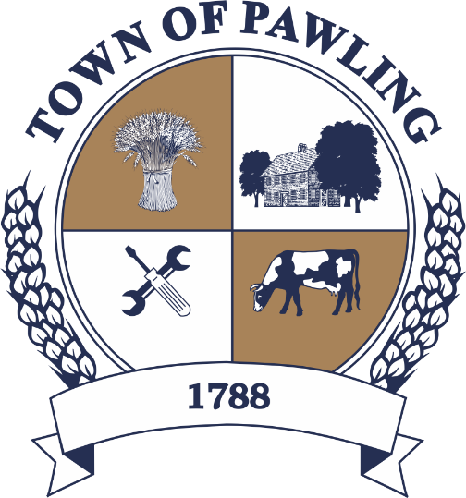
Town of Pawling Town Board
Pawling Town Hall
160 Charles Colman Blvd
Pawling, NY 12564

Regular Meeting of the Town Board

Meeting will be broadcast live on the Town of Pawling YouTube page

Wednesday, April 8, 2026
6:00PM

Cathy Giordano, Supervisor
Coleen Snow, Deputy Supervisor / Councilwoman
Martin Mygan, Councilman
James McCarthy, Councilman
Corinne Musella-Pitt, Councilwoman

Cheryl Knowles, Town Clerk

RULES FOR PUBLIC COMMENT:

1. Each presentation to the Board made by an individual shall be limited to three (3) minutes in duration, unless extended by agreement by the Town Supervisor/ designee

2. Comments should be directed to the Board. Comments should be made in a respectful manner to the Board and from the Board to the community.

The Town Supervisor or designee may:

a. Interrupt, warn, or terminate an individual’s comment when the comment is personally directed, abusive or obscene.

b. Request that any individual leave the meeting when that individual fails to observe reasonable decorum.

c. Call for a recess or an adjournment to another time.

The intent of these rules are:

1. To allow members of the public a fair and adequate opportunity to be heard.

2. To assure that the regular agenda of the Town Board is completed; and

3. To recognize the nature of the Board and community’s time and to use that time effectively.

Meeting Agenda

- Roll Call of the Town Board
- Pledge of Allegiance
- Public Comment on Agenda Items
- Presentations
- Resolutions
- Discussion
  - Holmes Whaley Lake Civic Association Dumpster proposal
- Town Board Items for Special Consideration & New Business
- Privilege of the Floor with respect to Agenda & Non-Agenda items (3 minutes)
- Adjournment

RESOLUTIONS
RESOLUTION 2026-071
Payment of Bills for the Town of Pawling
WHEREAS, The Town of Pawling Bookkeeper has reviewed and prepared the vouchers for Town of Pawling and has offered them for review, and

WHEREAS, the vouchers have been approved in accordance with the Town of Pawling policy, and

WHEREAS, the vouchers have been numbered 20260153 through 20260319, and

NOW THEREFORE BE IT RESOLVED, that the Town Board of the Town of Pawling hereby accepts the vouchers as prepared and on the recommendation of the Bookkeeper and hereby authorizes payment of said vouchers for the Town of Pawling on this date in the amount of $350,031.54.
RESOLUTION 2026-073
Facilities Use Request
WHEREAS, the Town of Pawling operates facilities that from time to time will be used by the public for events other than the town’s own usage, and

WHEREAS, the recreation director will periodically receive requests for special considerations once all applications and insurance requirements are met, and

WHEREAS, the town board of the Town of Pawling sets the fees for the use of facilities, and

NOW THEREFORE BE IT RESOLVED, that the following waiver(s) have been authorized by the town board: Nancy Lawlor – Alcohol Waiver, Alcohol Control Plan.

RESOLUTION 2026-083
Billing for Pawling Water District No. 2

WHEREAS, Pawling Water District No. 2 bills need to be approved by the Pawling Town Board, and

WHEREAS, the bills have been prepared and submitted in the amount of $14,124.85 for the period of January 1, 2026 through March 31, 2026 by the Clerk to the Water District, Cheryl Knowles, and

NOW THEREFORE BE IT RESOLVED, that the Town Board of the Town of Pawling hereby accepts the billing as recommended for Pawling Water District No.2

RESOLUTION 2026-084
Facilities Use Request
WHEREAS, the Town of Pawling operates facilities that from time to time will be used by the public for events other than the town’s own usage, and

WHEREAS, the recreation director will periodically receive requests for special considerations once all applications and insurance requirements are met, and

WHEREAS, the town board of the Town of Pawling sets the fees for the use of facilities, and

NOW THEREFORE BE IT RESOLVED, that the following waiver(s) have been authorized by the town board: Alexandra Mueller – Alcohol Waiver, Alcohol Control Plan.

RESOLUTION 2026-085
Facilities Use Request
WHEREAS, the Town of Pawling operates facilities that from time to time will be used by the public for events other than the town’s own usage, and

WHEREAS, the recreation director will periodically receive requests for special considerations once all applications and insurance requirements are met, and

WHEREAS, the town board of the Town of Pawling sets the fees for the use of facilities, and

NOW THEREFORE BE IT RESOLVED, that the following waiver(s) have been authorized by the town board: Elder Sagastume– Alcohol Waiver, Alcohol Control Plan

RESOLUTION 2026-086
Appointment – Part-Time Recreation Assistant

WHEREAS, a part-time Recreation Assistant vacancy exists in the Recreation Department, and
WHEREAS, the Recreation Director would like to fill this position by hiring Michael Morfea.
NOW THEREFORE BE IT RESOLVED, that the Town Board hereby appoints Michael Morfea as part-time Recreation Assistant at Town of Pawling Recreation at the rate of $15.00 per hour; and
BE IT FURTHER RESOLVED, that this appointment shall begin as of April 9th, 2026.

.

RESOLUTION 2026-087
Authorizing Stormwater Management Training for the Pawling Building Department

WHEREAS, the Town Board of the Town of Pawling finds it to be in the best interest of the Town to provide the Pawling Building Department with training in stormwater management practices and regulations; and

WHEREAS, Water R. Artus, CPESC of Stormwater Management Consultants, Inc. offers such municipality-specific trainings code enforcement and stormwater management at the rate of $125 per hour.
NOW, THEREFORE BE IT RESOLVED THAT, the Town Board of the Town of Pawling hereby authorizes Stormwater Management Consultants, Inc to provide such training to the Pawling Building Department at the rate of $125 per hour for up to 6 hours.

RESOLUTION 2026-088
Rescinding Prior Resolutions Relating to the Pawling Comprehensive Plan Committee

WHEREAS, on April 1, 2026, the Town Board of the Town of Pawling passed Resolution No. 2026-075 which reestablished and reconstituted the Pawling Comprehensive Plan Committee (CPC); and
WHEREAS, the Town Board wishes to clarify that Resolution No. 2026-075 is the controlling resolution and that any prior resolutions relating to the CPC.
NOW, THEREFORE BE IT RESOLVED THAT, the Town Board of the Town of Pawling hereby rescinds any prior resolution relating to the CPC to the extent that they may be deemed to be inconsistent with Resolution No. 2026-075.

RESOLUTION 2026-089
Establishment of Tree Board and Appointment of Members

WHEREAS, the Town Board of the Town of Pawling adopted a local law on September 14, 2022 providing for the establishment of a Tree Board (Pawling Town Code Chapter 53); and
WHEREAS, the Town Board has determined that it is in the best interest of the Town to formally establish the Tree Board and appoint members thereto in accordance with such local law.
NOW, THEREFORE, BE IT RESOLVED, that the Town Board hereby formally establishes the Town of Pawling Tree Board pursuant to the provisions Town Code Chapter 53; and
BE IT FURTHER RESOLVED, that the following individuals are hereby appointed to serve as members of the Town of Pawling Tree Board with the following staggered terms, pursuant to Town Code §53-3, to ensure continuity of service:

- Trevor Granger – three (3) year term
- Lori Asquith - three (3) year term
- Jim Thomas - two (2) year term
- James Bellucci - two (2) year term
- Mark Chipkin - one (1) year term
BE IT FURTHER RESOLVED, that upon expiration of the initial terms, all subsequent appointments shall be for a term of three (3) years; and
BE IT FURTHER RESOLVED, that the Tree Board shall select a Chair and Vice Chair from among its members; and
BE IT FURTHER RESOLVED, that the Town of Pawling Parks Department shall serve as staff liaison to the Tree Board to assist with coordination, implementation, and maintenance activities.

RESOLUTION 2026-090
Acceptance of Resignation

BE IT RESOLVED, that the Town Board upon the recommendation of the Town Supervisor hereby approves the letter of resignation of Employee #2026-01R effective at the close of business on April 8, 2026.

