Supervisor Cathy Giordano opened the meeting of the town board of the Town of Pawling at 6:00 PM on March 11, 2026 at Pawling Town Hall, 160 Charles Colman Blvd., Pawling, New York. Present were councilwoman Snow, councilmen Mygan and McCarthy and Sarah Ryan, town attorney. Councilwoman Pitt was absent. Approximately 10 interested citizens attended.

PRESENTATION / ROB STUCK AND MIKE MINERVA – EMPRESS AMBULANCE SERVICE

The town board entertained a presentation from Rob Stuck and Mike Minerva from Empress Ambulance Service. Mr. Stuck stated that the current ambulance contract will expire at the end of the year. The last contract was a five-year contract. He advised the board that the costs are continuing to go up. Mr. Stuck presented the town board with a new five-year proposal. The town board asked many questions and Mr. Stuck stated that he would provide additional documentation to the board this week.

RESOLUTIONS

RESOLUTION 2026-062
Payment of Bills for the Town of Pawling

WHEREAS, the Town of Pawling Senior Account Clerk has reviewed and prepared the vouchers for Town of Pawling and has offered them for review, and

WHEREAS, the vouchers have been approved in accordance with the Town of Pawling policy, and

WHEREAS, the vouchers have been numbered #20260001 through #20260152, and

NOW THEREFORE BE IT RESOLVED, that the town board of the Town of Pawling hereby accepts the vouchers as prepared and on the recommendation of the Senior Account Clerk and hereby authorizes payment of said vouchers for the Town of Pawling on this date in the amount of $2,133,830.86.

MOTION: Supervisor Giordano
SECOND: Councilman McCarthy

ROLL CALL VOTE:
Councilwoman Snow: “AYE”
Councilwoman Pitt: “ABSENT”
Councilman Mygan: “AYE”
Councilman McCarthy: “AYE”
Supervisor Giordano: “AYE”

RESOLUTION 2026-063
Authorizing Shared Services Agreement with Dutchess County Sign Shop

WHEREAS, the Town of Pawling intends to enter into an agreement between Dutchess County Department of Works that operate a Sign Shop that provides a wide variety of services including the manufacture of highway signs, and

WHEREAS, Dutchess County agrees to provide these services to the Town of Pawling under this shared services agreement, and

WHEREAS, the pricing for services are:
MUTCD Compliant Road Signs $0.09 per sq. in. of finished sign face

Building Signs $0.10 per sq. in of finished sign face

Stickers and adhesive lettering qty less than 100 units per design - $1.00 each
qty 100 or more units per design – $0.75 each

Highway Detour signs $0.10 per sq. in. of finished sign face

WHEREAS, this agreement shall be effective January 1, 2026 and shall terminate on December 31, 2026, and

NOW THEREFORE BE IT RESOLVED, that the Town Board of the Town of Pawling does hereby authorize the Supervisor to execute this agreement, as noted herein of the Shared Services Agreement.

MOTION: Supervisor Giordano
SECOND: Councilwoman Snow

ROLL CALL VOTE:
Councilwoman Snow: “AYE”
Councilwoman Pitt: “ABSENT”
Councilman Mygan: “AYE”
Councilman McCarthy: “AYE”
Supervisor Giordano: “AYE”

RESOLUTION 2026-064
Authorizing a Refund of Pro-rated Pawling Recreation Program Fee

BE IT RESOLVED, that the Town of Pawling Town Board hereby authorizes Pawling Recreation to issue a refund to Justine Gray in the amount of $170.00.

MOTION: Supervisor Giordano
SECOND: Councilman McCarthy

ROLL CALL VOTE:
Councilwoman Snow: “AYE”
Councilwoman Pitt: “ABSENT”
Councilman Mygan: “AYE”
Councilman McCarthy: “AYE”
Supervisor Giordano: “AYE”

RESOLUTION 2026-065
Authorizing Pawling Recreation to Establish a Program Enrollment Policy

WHEREAS, the Town Board of the Town of Pawling has observed that the Pawling Recreation Department has experienced significant arrears in its accounts stemming from non-payment of fees for programs and events; and

WHEREAS, the Town Board finds it necessary and appropriate for Pawling Recreation to establish a payment and registration policy designed to reduce the frequency of such nonpayment.

NOW, THEREFORE BE IT RESOLVED, that the Town Board hereby authorizes and directs Pawling Recreation to establish and implement an updated payment and registration policy.

MOTION: Supervisor Giordano
SECOND: Councilwoman Snow

ROLL CALL VOTE:
Councilwoman Snow: “AYE”
Councilwoman Pitt: “ABSENT”
Councilman Mygan: “AYE”
Councilman McCarthy: “AYE”
Supervisor Giordano: “AYE”

RESOLUTION 2026-066
Rejecting Request to Alienate a Portion of Dutcher Golf Course

WHEREAS, the Town Board of the Town of Pawling received a request to utilize a portion of Dutcher Golf Course for private parking; and

WHEREAS, the alienation of dedicated municipal parkland for a non-park purpose is a discretionary legislative action.

NOW, THEREFORE, BE IT RESOLVED THAT, the Town Board hereby declines to entertain said request or otherwise proceed with such alienation of the parkland.

MOTION: Supervisor Giordano
SECOND: Councilwoman Snow

ROLL CALL VOTE:
Councilwoman Snow: “AYE”
Councilwoman Pitt: “ABSENT”
Councilman Mygan: “AYE”
Councilman McCarthy: “AYE”
Supervisor Giordano: “AYE”

RESOLUTION 2026-067
Concept Approval for Intermunicipal Agreement Relating to Highway Department Shared Services

WHEREAS, Dutchess County, in conjunction with municipalities within the County, has proposed the creation of an Intermunicipal Agreement (IMA) to govern and permit shared services of personnel, equipment, and resources for highway and public works projects; and

WHEREAS, the sharing of such services will be promoted government efficiency, reduce taxpayer costs, and eliminate redundant services; and

WHEREAS, the County has provided a draft form of the proposed agreement for the municipalities’ review and concept review pending the provision of a final draft.

NOW, THEREFORE BE IT RESOLVED, that the Town Board of the Town of Pawling desires to participate in the IMA for shared highway services and equipment; and

BE IT FURTHER RESOLVED THAT, the Town Board approves the draft IMA pending the provision of the agreement in its final form.

MOTION: Supervisor Giordano
SECOND: Councilman McCarthy

ROLL CALL VOTE:
Councilwoman Snow: “AYE”
Councilwoman Pitt: “ABSENT”
Councilman Mygan: “AYE”
Councilman McCarthy: “AYE”
Supervisor Giordano: “AYE”

RESOLUTION 2026-068
Budget Amendments for Fiscal Year 2025

WHEREAS, a request for budget amendments has been received from the bookkeeper, and

WHEREAS, normal course of business activity throughout 2025 has prompted the bookkeeper to determine that various budget items should be amended,

NOW THEREFORE BE IT RESOLVED, that the bookkeeper has requested the following budget amendments.

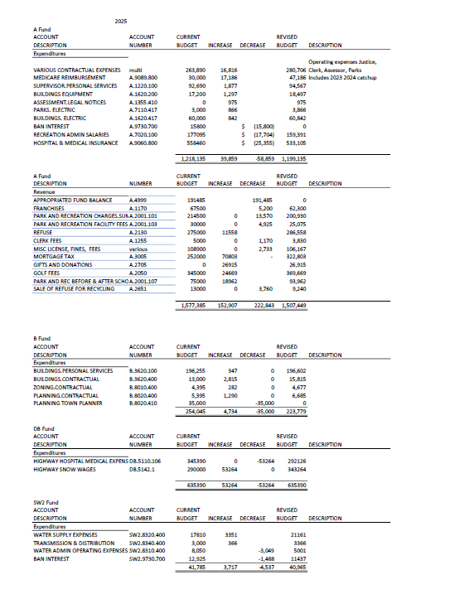

MOTION: Supervisor Giordano
SECOND: Councilwoman Snow

ROLL CALL VOTE:
Councilwoman Snow: “AYE”
Councilwoman Pitt: “ABSENT”
Councilman Mygan: “AYE”
Councilman McCarthy: “AYE”
Supervisor Giordano: “AYE”

DISCUSSION

SUPERVISOR GIORDANO
Supervisor Giordano stated that she and councilwoman Snow meet with Linda Grossman on Friday. She was recommended by Assemblyman Beephan for grant writing. Supervisor Giordano stated that Ms. Grossman wrote grants for the Pawling Central School District for 22 years and felt that it would be good for the town to have a local person writing some of the smaller grants for the town. Ms. Grossman’s fee is $40.00 per hour.

Supervisor Giordano stated that she had a meeting yesterday with Nick DeBenedetto from eBizDocs. This is the company that would do the scanning, should the town choose to go forward with the Laserfiche expansion project. Mr. DeBenedetto felt that we have a very good chance of receiving a $75,000 grant for this project. This is not a matching grant.

Supervisor Giordano also stated that another grant we would ask Linda Grossman to do, is the Hudson Valley Greenway grant, for the trails. This grant opportunity is another grant that Assemblyman Beephan advised us of.

Supervisor Giordano made a motion to authorize Linda Grossman to write Records Retention Grants through New York State Archives at the rate of $40.00 per hour, seconded by councilwoman Snow, motion passed unanimously.

COUNCILMAN MCCARTHY
Councilman McCarthy read the following statement.

I would like to congratulate Corinne. Tonight, while at the Putnam County Legislative meeting, Corinne is being recognized for a very special milestone during Women’s History month.

Putnam County is presenting Corinne with a proclamation for her becoming the first female to work her way through the ranks of the Putnam County Sheriff’s Office, to become the first female Police Captain in the history of the Sheriff’s Office. She is also being presented with a certificate from the Governor honoring her for this accomplishment.

COUNCILMAN MYGAN
Councilman Mygan stated registration opened up today for the next free rabies vaccine clinic, on Saturday, March 28th in Poughkeepsie. You can register on the Dutchess County Government Facebook page.

COUNCILWOMAN SNOW
Councilwoman Snow stated that there was ten new members being honored at the Fireman’s instillation dinner. She wanted to publicly thank them, as they are all volunteers.

Councilwoman Snow stated that she learned of two new upcoming grants; an MS4 grant and a grant from the county for Infrastructure.

The motion to adjourn the meeting was made by Supervisor Giordano at 6:40pm, seconded by Councilwoman Snow, motion passed unanimously.

Cheryl Knowles
Town Clerk

