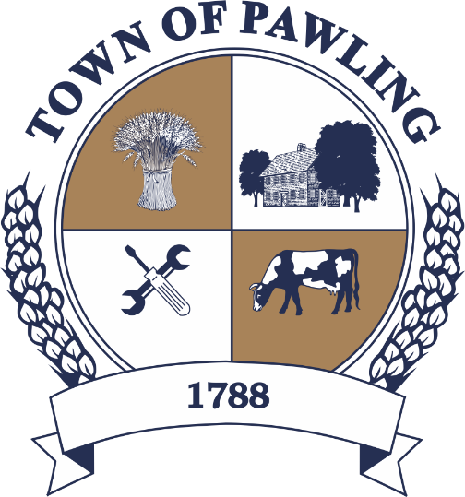
Town of Pawling Town Board
Pawling Town Hall
160 Charles Colman Blvd
Pawling, NY 12564

Special Meeting of the Town Board

Meeting will be broadcast live on the Town of Pawling YouTube page

Wednesday, May 27th, 2026
10:00AM

Cathy Giordano, Supervisor
Coleen Snow, Deputy Supervisor / Councilwoman
Martin Mygan, Councilman
James McCarthy, Councilman
Corinne Musella-Pitt, Councilwoman

Cheryl Knowles, Town Clerk

RULES FOR PUBLIC COMMENT:

1. Each presentation to the Board made by an individual shall be limited to three (3) minutes in duration, unless extended by agreement by the Town Supervisor/ designee

2. Comments should be directed to the Board. Comments should be made in a respectful manner to the Board and from the Board to the community.

The Town Supervisor or designee may:

a. Interrupt, warn, or terminate an individual’s comment when the comment is personally directed, abusive or obscene.

b. Request that any individual leave the meeting when that individual fails to observe reasonable decorum.

c. Call for a recess or an adjournment to another time.

The intent of these rules is:

1. To allow members of the public a fair and adequate opportunity to be heard.

2. To assure that the regular agenda of the Town Board is completed; and

3. To recognize the nature of the Board and community’s time and to use that time effectively.

Meeting Agenda

- Roll Call of the Town Board
- Pledge of Allegiance
- Resolutions
- Privilege of the Floor with respect to Agenda & Non-Agenda items (3 minutes)
- Adjournment

RESOLUTIONS
RESOLUTION 2026-112
RESOLUTION TO AWARD DEWEY LANE CULVERT REHABILITATION PROJECT
WHEREAS, the Town of Pawling is in the process of planning and permitting a public improvement project to rehabilitate the culvert on Dewey Lane over Hiller Brook (“Dewey Lane Over Hiller Brook Culvert Rehabilitation Project,” “Dewey Lane Culvert Rehabilitation Project,” or “the Project”); and
WHEREAS, the Town underwent a public bidding process for the Project, pursuant to the requirements of GML §103 and the Town of Pawling Procurement Policy; and
WHEREAS, four (4) bids were publicly opened, read aloud, and recorded by Town representatives on January 9, 2026; and
WHEREAS, the Town’s Engineer, HVEA Engineers, P.C., (“HVEA”), completed an evaluation of the four (4) lowest bids received and submitted a “Bid Analysis Memorandum” for the Town Board’s review and consideration; and
WHEREAS, T&A Construction, Inc. (“T&A Construction”) submitted the lowest bid of $674,619.00 to perform the work; and
WHEREAS, after a detailed evaluation, HVEA recommended that the Contract be awarded to T&A Construction, Inc. as the lowest responsible bidder; and
WHEREAS, HVEA submitted a contract award documentation package to the NYS Department of Transportation (“NYS DOT”) on March 24, 2026; and
WHEREAS, the NYS DOT determined that the submitted documentation of the construction contract bidding and award process was complete and satisfactory and, on May 18, 2026, issued an award concurrence; and
NOW, THEREFORE BE IT RESOLVED, that the Town Board hereby finds that T&A Construction, Inc was the lowest responsible bidder for the Dewey Lane Culvert Rehabilitation Project; and
BE IT FURTHER RESOLVED, that the Town Board hereby awards the Contract to T&A Construction, Inc for the bid price of $674,619.00; and
BE IT FURTHER RESOLVED, that the Town Board hereby directs and authorizes that a Notice of Award and Contract be sent to T&A Construction, Inc., accordingly.
RESOLUTION 2026-113
APPOINTMENT – PART TIME RECREATION CLUB ASSISTANT
WHEREAS, a part-time Recreation Club Assistant vacancy exists in the Recreation Department, and
WHEREAS, the Recreation Director would like to fill this position by hiring Emily Mascia.
NOW THEREFORE BE IT RESOLVED, that the Town Board hereby appoints Emily Mascia as part-time Recreation Club Assistant at Town of Pawling Recreation at the rate of $17.00 per hour; and
BE IT FURTHER RESOLVED, that this appointment shall begin as of May 27th, 2026.

