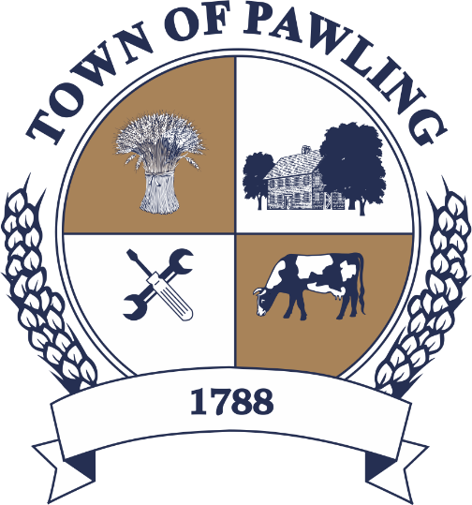
Town of Pawling Town Board
Pawling Town Hall
160 Charles Colman Blvd
Pawling, NY 12564

Special Meeting of the Town Board

Meeting will be broadcast live on the Town of Pawling YouTube page

Wednesday, July 22nd, 2026
9:00AM

Cathy Giordano, Supervisor
Coleen Snow, Deputy Supervisor / Councilwoman
Martin Mygan, Councilman
James McCarthy, Councilman
Corinne Musella-Pitt, Councilwoman

Cheryl Knowles, Town Clerk

RULES FOR PUBLIC COMMENT:

1. Each presentation to the Board made by an individual shall be limited to three (3) minutes in duration, unless extended by agreement by the Town Supervisor/ designee

2. Comments should be directed to the Board. Comments should be made in a respectful manner to the Board and from the Board to the community.

The Town Supervisor or designee may:

a. Interrupt, warn, or terminate an individual’s comment when the comment is personally directed, abusive or obscene.

b. Request that any individual leave the meeting when that individual fails to observe reasonable decorum.

c. Call for a recess or an adjournment to another time.

The intent of these rules is:

1. To allow members of the public a fair and adequate opportunity to be heard.

2. To assure that the regular agenda of the Town Board is completed; and

3. To recognize the nature of the Board and community’s time and to use that time effectively.

Meeting Agenda

- Roll Call of the Town Board
- Pledge of Allegiance
- Resolutions
- Privilege of the Floor with respect to Agenda & Non-Agenda items (3 minutes)
- Adjournment

RESOLUTIONS
RESOLUTION 2026-145
Authorizing the Comcast Business Service Order Agreement for the Teen Center

WHEREAS, the Town Board of the Town of Pawling finds that the purchase of a new router is desirable to improve internet speed and reliability at the Teen Center; and

WHEREAS, the proposed package from Comcast Business includes Business Internet Performance, Security Edge, and one (1) Mobility Voice Line at the rate of $172.94 for months 1-24; and

WHEREAS, this service is expected to result in savings of approximately $300 each month when compared to current costs.

NOW, THEREFORE BE IT RESOLVED, that the Town Board hereby authorizes the above describe change of service and associated Service Order Agreement; and

BE IT FURTHER RESOLVED, that the Town Board authorizes the Town Supervisor or her designee to execute the documentation or agreements necessary to effectuate this agreement.

RESOLUTION 2026-146
Authorizing the Town Supervisor to submit a grant application to the NYSDEC for the
2026 Climate Smart Communities Grant Program for Solar Panel Project
WHEREAS, the Town of Pawling seeks to secure funding for the Solar Panel Project on 5 Town Buildings.
WHEREAS, funding is available through the NYSDEC Climate Smart Communities Grant Program.
NOW THEREFORE BE IT RESOLVED, that the Town Board hereby authorizes the Town Supervisor to submit a grant to the NYS Department of Environmental Conservation for the 2026 Climate Smart Communities Grant Program and to sign any documents required.
BE IT FURTHER RESOLVED, that the Town authorizes a financial match of 50%, estimated to be less than $381,500 using budgeted funds, capital reserves, or bond proceeds. The Town will separately pursue and estimated $198,000 elective tax credit which will be returned to the General Fund and not reduce the Town’s initial 50% match commitment.

RESOLUTION 2026-147
Approving Special Event Permit for Pawling Fire Department

WHEREAS, the Pawling Fire Department has applied for a Special Event Permit to hold its annual carnival on August 5, 2026 through August 8, 2026 in Lakeside Park; and
WHEREAS, Ken Clair, Building Inspector has reviewed the application, found it to be complete, and has recommended its approval by the Town Board; and
WHEREAS, the Fire Department has submitted a written request for the waiver of fees.
NOW THEREFORE BE IT RESOLVED, that the Town Board of the Town of Pawling hereby approves the Special Event Permit for the Pawling Fire Department; and
BE IT FURTHER RESOLVED, that in recognition of the Fire Department’s service to the community, the Town Board hereby waives the fees associated with the application.
RESOLUTION 2026-148
Approving Special Event Permit for Pawling Community Foundation

WHEREAS, the Pawling Community Foundation has applied for a Special Event Permit to hold its fundraising gala on October 10, 2026 in Lakeside Park; and
WHEREAS, Everett White, Building Inspector has reviewed the application, found it to be complete, and has recommended its approval by the Town Board; and
WHEREAS, Wendel Weber, Supervisor of Buildings and Grounds, has provided an estimated reimbursement fee for use of Town property and staff for the event in the amount of $3,065.36.
NOW THEREFORE BE IT RESOLVED, that the Town Board of the Town of Pawling hereby approves the Special Event Permit for the Pawling Community Foundation; and
BE IT FURTHER RESOLVED, that the Town Board hereby sets a fee of $3,065.36 for the Permit.

RESOLUTION 2026-149
Authorizing the Transfer Station to Temporarily Accept Debris from Storm Event

WHEREAS, the Town Board find that town residents have experienced an increase in residential debris due to recent storm events, and
WHEREAS, to offset the impacts of the storms, it is desirable to open the Transfer Station to all town residents, who may or may not hold current transfer station permits, for the limited purpose of allowing residential storm debris to be dropped off at said transfer station; and
NOW THEREFORE BE IT RESOLVED, that the Town Board of the Town of Pawling hereby allows the temporary open use of the Transfer Station for the disposal of residential storm debris by residents upon the following conditions:
- Debris may be dropped off on any day the Transfer Station is open for regular operations (Mon, Thurs, Sat).
- Residential debris which is no larger than 12 inches in diameter shall be accepted.
- The Transfer Station attendant shall allow access upon adequate proof of residency; and
BE IT FURTHER RESOLVED, that this temporary measure shall cease after August 8, 2026.

RESOLUTION 2026-150
Authorizing the Town Highway Superintendent to Advertise for Bids for Tree Work
WHEREAS, the Town Highway Superintendent has identified a need for a contractor to perform tree work in the Town of Pawling; and
WHEREAS, the Town Board finds that is in the Town’s best interest to seek bids from companies that can perform such necessary work.
NOW THEREFORE BE IT RESOLVED, that the Town Board hereby authorizes the Town Highway Superintendent to advertise for and seek bids for tree work.

